Tuple as a return value
A function can only return one value, but if the value is a tuple, the effect is the same as returning multiple values. For example, if you want to divide two integers and compute the quotient and remainder, it is inefficient to compute x//y and then x%y. It is better to compute them both at the same time.
The built-in function divmod takes two arguments and returns a tuple of two values, the quotient and remainder. You can store the result as a tuple:
>>> t = divmod(7, 3)
>>> t
(2, 1)
Or use tuple assignment to store the elements separately:
>>> quot, rem = divmod(7, 3)
>>> quot
2
>>> rem
1
Here is an example of a function that returns a tuple:
def min_max(t):
return min(t), max(t)
max and min are built-in functions that find the largest and smallest elements of a sequence. min_max computes both and returns a tuple of two values.
Example:
def circleInfo(r):
""" Return (circumference, area) of a circle of radius r """
c = 2 * 3.14159 * r
a = 3.14159 * r * r
return (c, a)

print(circleInfo(10))
(62.8318, 314.159)

Nested Tuples in Python
A nested tuple is a Python tuple that has been placed inside of another tuple. Let's have a look at the following 8-element tuple.
- tuple = (12, 23, 36, 20, 51, 40, (200, 240, 100))
This last element, which consists of three items enclosed in parenthesis, is known as a nested tuple since it is contained inside another tuple. The name of the main tuple with the index value, tuple[index], can be used to obtain the nested tuple, and we can access each item of the nested tuple by using tuple[index-1][index-2].

Example of a Nested Tuple
Code
- # Python program to create a nested tuple

- # Creating a nested tuple of one element only
- employee = ((10, "Itika", 13000),)
- print(employee)

- # Creating a multiple-value nested tuple
- employee = ((10, "Itika", 13000), (24, "Harry", 15294), (15, "Naill", 20001), (40, "Peter", 16395))
- print(employee)
Output:
((10, 'Itika', 13000),)
((10, 'Itika', 13000), (24, 'Harry', 15294), (15, 'Naill', 20001), (40, 'Peter', 16395))

Some Operations of Nested Tuples
We will see two necessary operations of nested tuples.

Concatenating Tuples to Nested Tuples
When dealing with tuples, it's occasionally necessary to turn separate records into a nested group while keeping them as independent elements. Tuples are often added by adding the contents, which flattens the resulting container, which is typically undesirable. Let's talk about some approaches to solving this issue.
Using the + operator and "," during initialization
In this technique, we add tuple members as we do, but when initializing tuples, we append a comma after each tuple to prevent flattening during addition.
Code
- # Python program to concatenate tuples to make a nested tuple

- # initializing the tuples
- tup1 = (5, 4),
- tup2 = (1, 6),

- # printing the original tuples
- print("Tuple 1 : " + str(tup1))
- print("Tuple 2 : " + str(tup2))

- # Concatenating the two tuples to a nested tuple using the + operator
- nested = tup1 + tup2

- # printing the result
- print("The nested tuple : " + str(nested))
Output:
Tuple 1 : ((5, 4),)
Tuple 2 : ((1, 6),)
The nested tuple : ((5, 4), (1, 6))

Using the "," Operator
This task can be performed by applying the "," operator during concatenation. It can perform safe concatenation.
Code
- # Python program to concatenate tuples to make a nested tuple

- # initializing the tuples
- tup1 = (5, 4)
- tup2 = (1, 6)

- # printing the original tuples
- print("Tuple 1 : " + str(tup1))
- print("Tuple 2 : " + str(tup2))

- # Concatenating the tuples by using the ", "operator after tuples
- nested = ((tup1, ) + (tup2, ))

- # printing result
- print("The nested tuple " + str(nested))
Output:
Tuple 1 : (5, 4)
Tuple 2 : (1, 6)
The nested tuple ((5, 4), (1, 6))

Python Tuple: Tuple Functions and Tuple Operations in Python

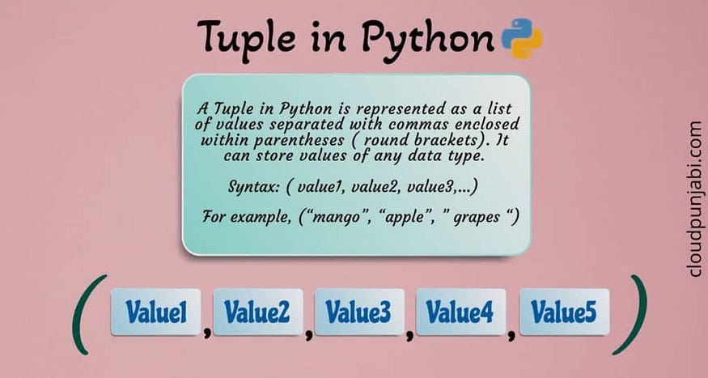

What is a tuple in Python?
A Tuple in Python is represented as a list of values separated with commas enclosed within parentheses ( round brackets). It can store values of any data type.
For example, (“mango”, “apple”, “dragon fruit”, ” grapes “) is a tuple.

Tuple Operations in Python
It is the computation or actions applied to the variable containing tuple data types in an expression.
Like List manipulation, Tuple manipulation in Python can be done using various operators like concatenation (+), repetition (*), slicing of the tuple, and membership operators( in /not in). So, Let’s understand each operator in brief.

1. Concatenation operator (+)
The (+) operator is used to add to two tuples.
The syntax of the given operation is: Tuple1+Tuple2
t1=(12, 34, 56)
t2=(78, 90)
print(t1+t2)#

Output
(12, 34, 56, 78, 90)

2. Repetition operator (*)
Like string and list, (*) operator replicates the element of the tuple of specified times.
The syntax of the given operation: Tuple*n
t1=(12, 34, 56)
print( t1*3)#

Output
(12, 34, 56, 12, 34, 56, 12, 34, 56)

3. Comparison Operator
Python offers standard comparison operators like ==,<, >, != to compare two lists.
For comparison, two tuples must-have elements of comparable types, otherwise, you will get an error.
Python gives the result of comparison operators as True or False and moreover, it compares tuple list element by element. It compares the first element if they are the same then will move to the next, and so on.

5. Membership Operator (in, not in)
The membership operator checks whether an element exists in the given tuple sequence.
- in: Return True if an element exists in the given tuple; False otherwise
- not in: Return True if an element does not exist in the given tuple; False otherwise.
t1=(12, 34, 56, 78, 90)
#membership operator
56 in t1
12 not in t1#

Output
True
False

Tuple Functions in Python
Python offers many built-in methods and functions that perform specific actions on the given tuple. Let’s discuss these functions:
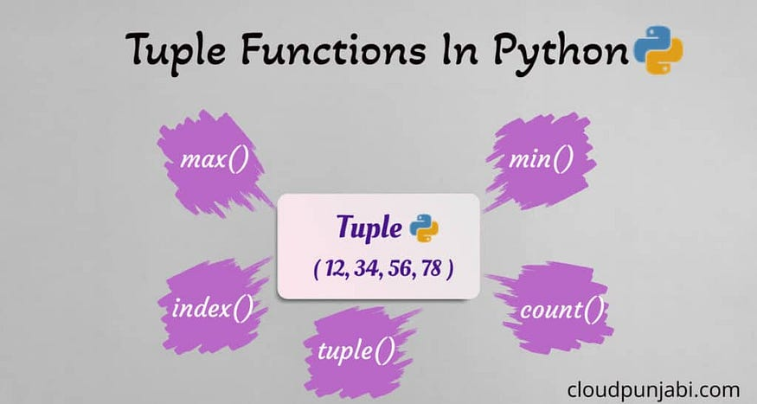

1. The max() method
This tuple method returns the element which has a maximum value from the given tuple.
Syntax: max( sequence)
t1 =( 12, 34, 56, 78 )
print( max(t1))#

Output
78

2. The min() method
The min method() returns the element which has a minimum value from the given tuple.
Syntax: min( sequence)
t1 =( 12, 34, 56, 78 )
print( min(t1))#

Output
12

3. The index() method
The index() method returns the index of an existing element of the given tuple.
Syntax: <tuple>. index( <name>)
t1= ( 12, 34, 56, 78)
t1.index(56)#

Output
2

4. The count() method
The count() method returns the count of an element in a given sequence i.e, it counts occurrences of an element in the given tuple.
Syntax: <tuple>.count(<element>)
t1= (2, 4, 6, 7, 8, 3, 4, 6 ,7 , 29, 9 , 4)
t1.count(4)#

Output
3

5. The tuple() method
The tuple() method is a constructor method that is used to create tuples from different types of values.
Syntax: tuple()
list1=[12,34,56]
t1= tuple( list1)
print(t1)#

Output
(12,34, 56)

